**==========================================================**

**Windows forms Application**

**Lab 3 (week 5, 6)**

=====================================================================================

**Goals:**

The goal of Lab 3 is to develop a Windows Forms Application named Library system described in document “List of sample projects”.

**System description:**

Your system must have the following functions:

1. Register members (add/edit/delete)
2. Register book and its copies (add/edit/delete)
3. Borrow copies
4. Return copies
5. Reserve a book

Your program output may be look like:

1. Main window form

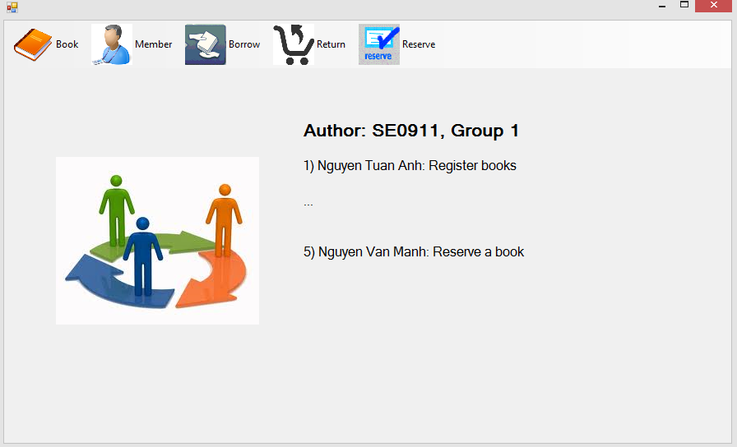

Requirements: Display class ID, Group ID, and the list of members with his/her function.

1. Register books and their copies

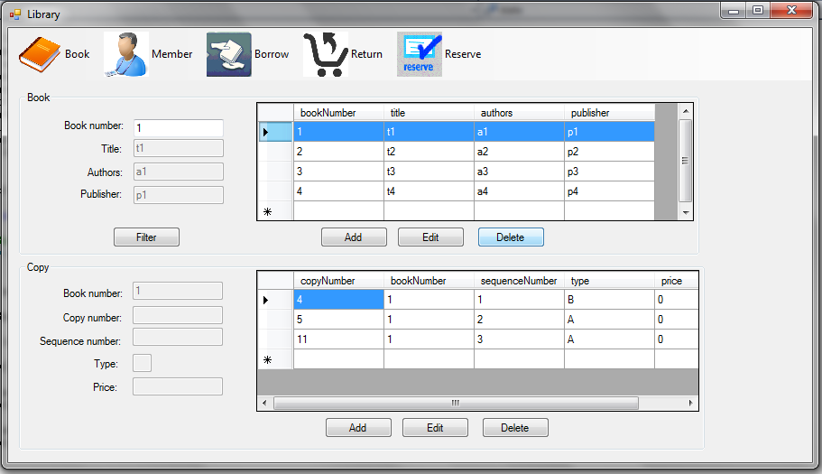

Requirements:

* List all books and its copies.
* Display the book/copy information in text boxes when a book/copy is selected.
* Filter books by book number (click the button ‘Filter’).
* Add a new book:
  + Click button ‘Add’, then the label of this button will be changed to ‘Save’, and the system will allow you to enter a new book information in the text boxes.
  + Enter a new book information.
  + Click the button ‘Save’ to add this book into Database.
* Edit a book:
  + Select a book in the list.
  + Click the button ‘Edit’, and the label of this button will be changed to “Save”, and the system will allow you to edit this book information.
  + Edit this book information.
  + Click the button ‘Save’ to update this book into Database.
* Delete a book:
  + Select a book in the list.
  + Click the button ‘Delete’, then the system will display the ‘Confirm deleting’ dialog, click the button ‘Yes’ to delete this book.
* Add a new copy of a book
  + Select a book in the list.
  + Click the button ‘Add’, then the label of this button will be changed to ‘Save’, and the system will allow you to enter a new copy information.
  + Enter a new copy information (type of copy must be ‘A’ or ‘R’).
  + Click the button ‘Save’ to add a new book into Database.
* Edit a copy.
  + Select a copy in the list
  + Click the button ‘Edit’, then the label of this button will be changed to ‘Save’, and the system will allow you to edit this copy information.
  + Click the button ‘Save’ to update this copy information into Database
* Delete a copy
  + Select a copy in the list.
  + Click the button ‘Delete’, then the system will display the ‘Confirm deleting’ dialog, click the button ‘Yes’ to delete this copy

1. Register members

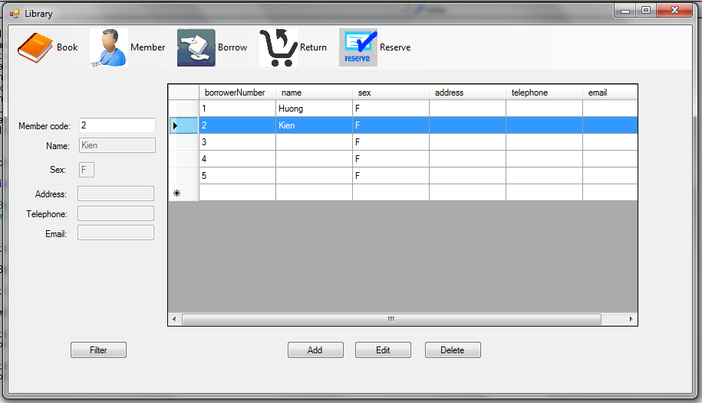

Requirements:

* List all members.
* Display a member information in the text boxes when a member is selected.
* Filter members by member code (click the button ‘Filter’).
* Add a new member
  + Click the button ‘Add’, then the label of this button will be changed to ‘Save’, and the system will allow you to enter a new member information.
  + Enter a new member information.
  + Click the button ‘Save’ to add a new member into Database.
* Edit a member
  + Select a member in the list.
  + Click the button ‘Edit’, then the label of this button will be changed to ‘Save’, and the system will allow you to edit this member information.
  + Edit this member information.
  + Click the button ‘Save’ to update this member information into Database.
* Delete a member
  + Select a member in the list.
  + Click the button ‘Delete’, then the system will display the ‘confirm deleting’ dialog, click the button ‘Yes’ to delete this member.

1. Borrow copies

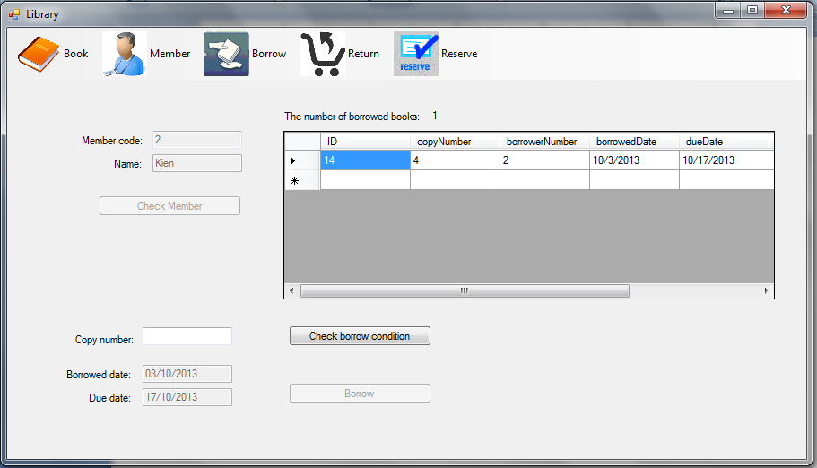

Requirements: Steps to borrow a copy:

* Enter member code, then click the button ‘Check member’. The system will display this member information and the list of copies he/she borrowed.
* Enter copy number, then click the button ‘Check borrow condition’. He/she can borrow this copy, if:
  + The number of copies he/she borrowed <= 5.
  + This copy is available and its book is not in the reservation list or you must be in the head of reservation list.
* Enter the borrowed date. The system will display the due date.
* Click the button ‘Borrow” to borrow this copy.

1. Return copies

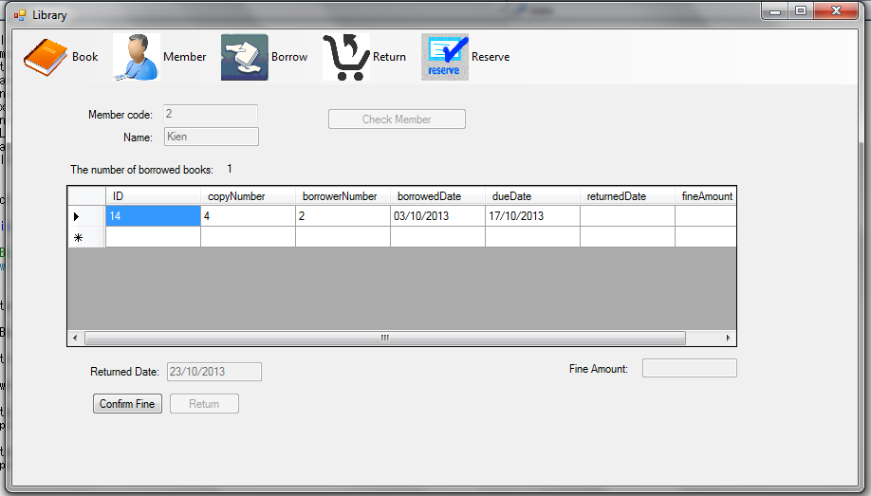

Requirements: steps to return a copy

* Enter member code, then click the button ‘Check member’. The system will display this member information, and the list of copies borrowed by him/her.
* Select a copy in the list.
* Enter the return date.
* Click the button ‘Confirm Fine”. The system will display fine amount (1 USD per 1 delay day). Note that return date is the system date.
* Click the button ‘Return’ to return this copy.

1. Reserve a book

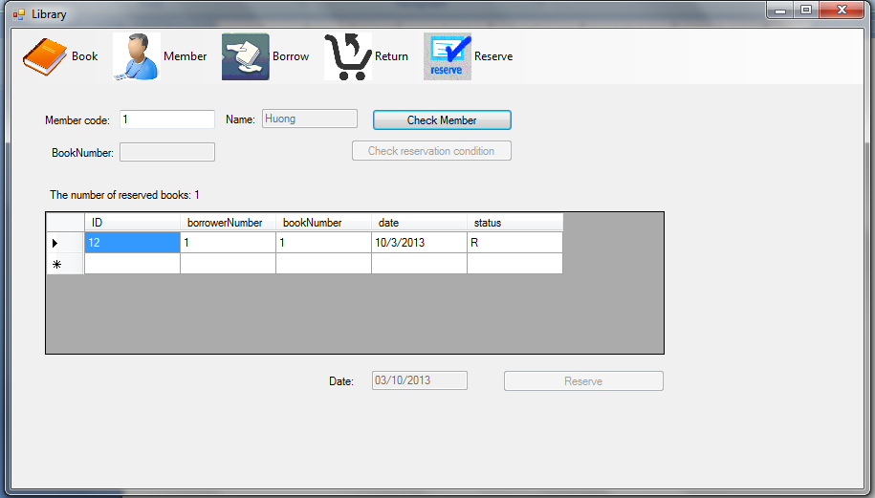

Requirements: Steps to reserve a book:

* Enter member code, then click the button ‘Check Member’. The system will display this member information and the list of books he/she reserved.
* Enter book number, then click the button ‘Check reservation condition’. He/she can reserve this book if:
  + He/she doesn’t reserve any book at the moment.
  + All copies of this book are borrowed.
* Enter the reservation date, then click the button ‘Reserve’ to reserve this book.

**References:**

* Document “List of sample projects”.
* Software design of Library system: “SD_Library system”.
* Format data in Windows Forms DataGridView control: <http://msdn.microsoft.com/en-us/library/f9x2790s%28v=vs.90%29.aspx>

**Note:**

* Use date format “dd/MM/yyyy” and default date is the system date.
* Use Database “Library” given in site “cms” and must use “localhost\SQLExpress” for the name of DB server .
* Your solution name: GroupN_Lab3, and file name : ClassID_GroupN_Lab3.zar, where N = 1, or 2…